
American International University-Bangladesh (AIUB)
Department of Computer Science
Faculty of Science &Technology (FST)
FALL 25 26
Section: A
Software Quality Assurance and Testing
Smart Health Advisory and Awareness System
A Report submitted
By

SN | Student Name | Student ID
1 | ZOBAYER ISLAM JONY | 22-48179-2
2 | SHEMANTO | 22-48653-3
3 | AFIA SULTANA | 22-47097-1
4

Checked By Industry Personnel (Optional)

Name:

Designation:

Company:

Sign:

Date:

Software Test Plan

for
Smart Health Advisory and Awareness System (SHAAS)
Version 1.0 approved
Prepared by Zobayer Islam Jony, Shemanto, Afia Sultana
American International University-Bangladesh (AIUB)
Date Created: 01-01-2026

Table of Contents
Revision History 3
1. TEST PLAN IDENTIFIER: RS-MTP01.3 3
2. REFERENCES 3
3. INTRODUCTION 3
Background to the Problem 3
Solution to the Problem 4
4. REQUEIREMNT SPECIFICATION 4
4.1 System Features 4
4.2 System Quality Attributes 4
4.3 System Interface 5
4.4 Project Requirements 5
5. FEATURES NOT TO BE TESTED 5
6. TESTING APPROACH 5
6.1 Testing Levels 5
6.2 Test Tools 6
6.3 Meetings 6
7. TEST CASES/TEST ITEMS 6
8. ITEM PASS/FAIL CRITERIA 7
9. TEST DELIVERABLES 7
10. STAFFING AND TRAINING NEEDS 8
11. RESPONSIBILITIES 8
12. TESTING SCHEDULE 8
13. PLANNING RISKS AND CONTINGENCIES 9
14. APROVALS 9

Revision History
Revision | Date | Updated by | Update Comments
1 | 01-01-26 | Zobayer Islam Jony | Initial draft (scope + outline).
2 | 03-01-26 | Shemanto | Updated requirements, approach, and tools.
3 | 05-01-26 | Afia Sultana | Added detailed test cases and criteria.
4 | 08-01-26 | Zobayer Islam Jony | Added schedule and risk plan.
5 | 15-01-26 | Team | Final review and formatting.

TEST PLAN IDENTIFIER: Smart Health Advisory and Awareness System (SHAAS) — RS-MTP01.3

REFERENCES
- Software Requirement Specification (SRS) for Smart Health Advisory and Awareness System (SHAAS), Version 1.0
- UI prototypes and wireframes
- Database schema and API documents
- Security and privacy guidelines
- Third-party documentation (Maps/GPS, Weather/AQI, Notifications, Payment)

INTRODUCTION

Background to the Problem

People often need quick, reliable health guidance, but available information is scattered, confusing, or not personalized. Many also do not track basic health indicators like weight, activity, sleep, or hydration, which can lead to delayed care and preventable health issues.
Proposed Solution:
SHAAS is a user‑centric platform (mobile/web) that combines a personal health profile, calculators (e.g., BMI), reminders/notifications, environmental awareness (weather/AQI), and guided assistance via an AI advisor. The solution is appropriate because it converts health information into practical steps (tips, alerts, and simple tracking) while keeping medical decisions with licensed professionals. It is feasible using standard secure authentication, scalable APIs, and established third‑party services.
Objectives and Benefits:
• Encourage preventive health behavior through daily tips and timely alerts.
• Enable users to monitor common metrics with manual logging and optional passive tracking.
• Provide quick access to support: doctor appointment booking, live chat, and helpline contacts.
• Maintain strong privacy and security controls to protect user data.
Existing Solutions:
Existing options include fitness trackers, standalone BMI calculator apps, and health information sites. However, many solutions are single‑purpose and do not provide a unified workflow that connects personal profile data, reminders, environment context, and support channels. SHAAS consolidates these capabilities in one system to improve convenience and overall awareness.

REQUEIREMNT SPECIFICATION

System Features
Functional Requirements (System Features):
FR-01: Free Trial (3 days)
- Priority: High | Precondition: None
- Users can try premium features for 3 days. The system tracks start/end time and reminds them to upgrade.
FR-02: Sign Up (Email/Phone + OTP)
- Priority: High | Precondition: None
- Users can create an account using email or phone. OTP confirms their identity.
FR-03: Log In
- Priority: High | Precondition: User account exists
- Users log in with correct credentials. Too many failed attempts may lock the account temporarily.
FR-04: Forgot Password (OTP Reset)
- Priority: High | Precondition: Registered email/phone
- Users can reset password using OTP and follow password rules.
FR-05: User Profile
- Priority: High | Precondition: User logged in
- Users can view and update personal info and preferences.
FR-06: Notification Alerts
- Priority: High | Precondition: User logged in
- System sends reminders for medicine, water, appointments, and health updates.
FR-07: Health Tracking
- Priority: High | Precondition: User logged in
- Users can log health data manually or use sensors for automatic tracking.
FR-08: AI Health Advisor
- Priority: Medium | Precondition: User logged in
- Provides general health tips, answers questions, and suggests app features safely.
FR-09: Appointment Booking
- Priority: High | Precondition: User logged in
- Users can book doctor appointments and get confirmations/reminders.

System Quality Attributes
Non-Functional Requirements (Quality Attributes):
- Security: Keep user data safe with HTTPS, strong password hashing, OTP verification, and role-based access.
- Data Privacy: Collect only needed data with consent; let users control sharing; follow retention rules.
- Reliability: App should handle failures smoothly, support retries, and avoid crashes.
- Performance: Dashboard and main features should load fast; use caching and API timeouts.
- Usability: Easy navigation, simple forms, clear messages, consistent UI across screens.
- Compatibility: Work on common Android versions and modern browsers; adapt to different screen sizes.
- Accessibility: Text readable, support screen readers, and allow keyboard navigation on web.
- Scalability: Handle more users and future features without major redesign.
- Maintainability: Modular code, version control, code reviews, and automated testing for easy updates.

System Interface
The wireframes below represent key interfaces used for functional testing of SHAAS. They help validate required fields, navigation flow, and user-visible outputs during execution.

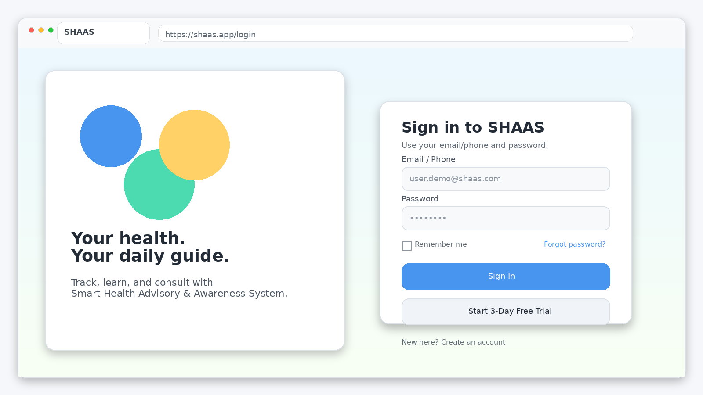
Figure 1: Login Screen (Web Browser UI)
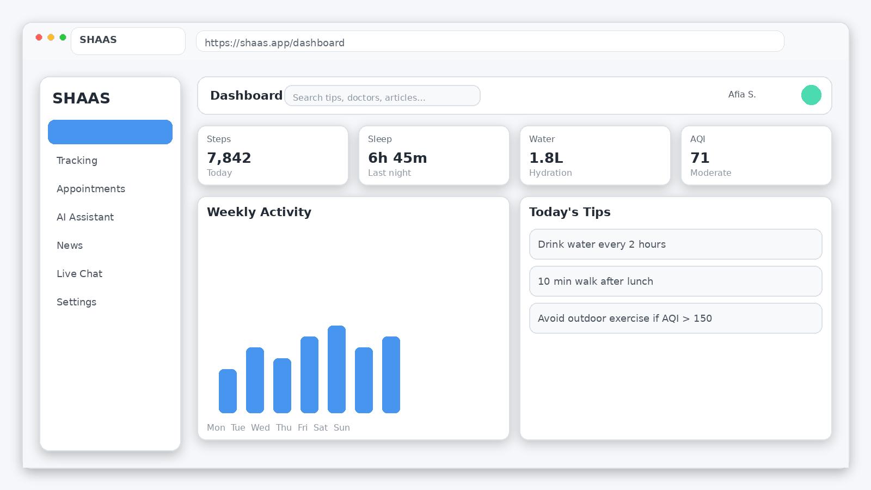
Figure 2: Dashboard Screen (Web Browser UI)

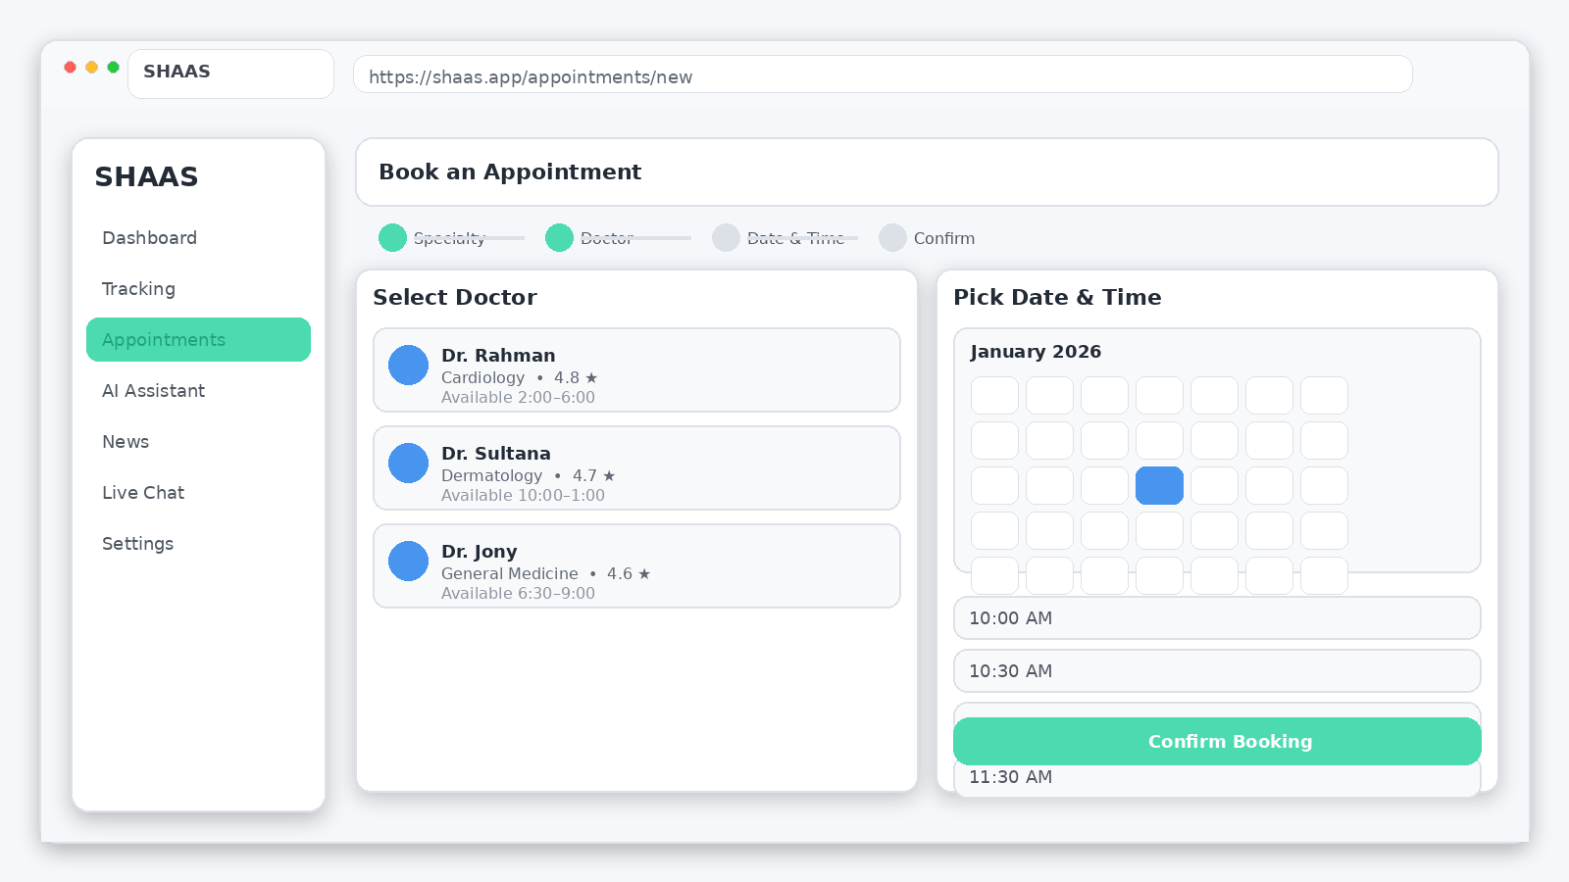
Figure 3: Appointment Booking Screen (Web Browser UI)
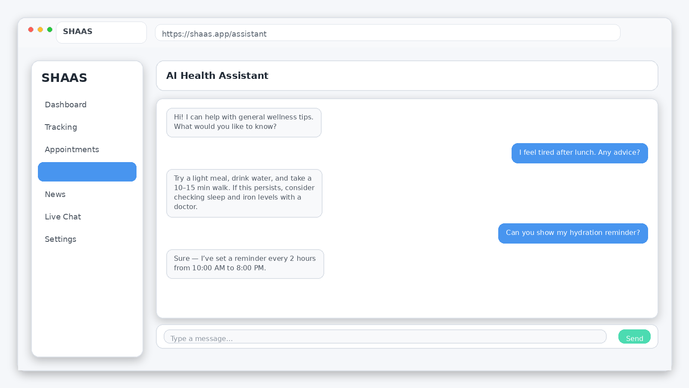
Figure 4: AI Assistant Screen (Web Browser UI)

Project Requirements
- Project Constraints and Assumptions:
- Testing Window: 01 Jan 2026 – 15 Jan 2026
- Estimated Budget: 3,90,000 BDT
- Development & UI/UX: 2,10,000 BDT
- QA & Testing: 80,000 BDT
- Cloud/Hosting & API: 50,000 BDT
- Contingency/Misc.: 50,000 BDT
- Development Time: 16 weeks (8 sprints × 2 weeks) + 2 weeks buffer
- Team Resources: 1 Product Owner, 1 Scrum Master, 3 Developers, 1 QA Engineer
- Tools & Environment: VS Code, Android Studio, MySQL/PostgreSQL, Git, Figma, staging server
- Constraints: Limited testing devices, API rate limits, strict health data privacy requirements

FEATURES NOT TO BE TESTED
The following will not be tested directly (only indirectly if related to app features):
- Internal workings of third-party services (maps, weather/AQI, payment, notifications). Only integration and response handling will be tested.
- Hardware/sensor precision differences (GPS, step counter). Only correct reading and display of OS-provided values will be checked.
- User-modified external files (e.g., exported reports opened in other apps or spreadsheets).
- Carrier or network outages beyond our control. Only graceful handling will be tested.
- Clinical diagnosis or treatment accuracy. Only general health guidance is provided; doctor decisions are out of scope.

TESTING APPROACH

Testing Levels
- SHAAS will be tested in four levels: Unit, Integration, System, and Acceptance. Developers perform unit tests for each module (e.g., BMI calculation, OTP verification) before promotion to staging. QA conducts integration and system tests to ensure smooth data flow, end-to-end workflows, UI consistency, database updates, and error handling. Finally, stakeholders perform acceptance testing (UAT) to confirm the system meets business goals and works in real scenarios, with sign-off granted only if all critical workflows pass and no critical defects remain.

Test Tools
Tools and Utilities:
SHAAS testing will use Appium (Android UI automation), Selenium WebDriver (web UI, if applicable), Postman/Newman (API testing), JMeter (load/performance testing), and OWASP ZAP (security scanning). Testing will be done on Android Studio emulator and physical devices. Git and issue trackers (GitHub/Jira/Trello) manage versioning and defects, while Figma prototypes guide UI validation.

Meetings
• QA Stand‑up: Every 2 days during the testing window (Jan 01–Jan 15) to update progress, defects, and blockers.
• Weekly Review: Once per week to review metrics, defect trends, and re‑prioritize testing if needed.
• Cross‑team Sync (QA + Dev + PO): At least two meetings (mid‑window and pre sign‑off) for triage and release readiness.
• Critical defect meeting: on‑demand when a blocking issue occurs.

TEST CASES/TEST ITEMS
The following test cases are prepared for SHAAS to validate core functionality, security, and usability within the defined scope.
Project Name: Smart Health Advisory and Awareness System (SHAAS) |  |  | Test Designed by: Zobayer Islam Jony
Test Case ID: SHAAS-001 |  |  | Test Designed date: 01/01/2026
Test Priority (Low, Medium, High): High |  |  | Test Executed by: Shemanto
Module Name: Sign In Session |  |  | Test Execution date: 03/01/2026
Test Title: Verify login with valid username and password
Description: Test that a user can sign in using correct credentials and reach the dashboard.
Precondition (If any): User must have a registered account and internet access.
Test Steps | Test Data | Expected Results | Actual Results | Status (Pass/Fail)
1. Open the application.  2. Navigate to Sign In screen.  3. Enter valid email/phone.  4. Enter valid password.  5. Tap Submit / Sign In. | Email: user.demo@shaas.com  Password: Demo@1234 | User successfully logs in and is redirected to Home/Dashboard. | As expected. | Pass
Post Condition: Session token created; dashboard loads.

Project Name: Smart Health Advisory and Awareness System (SHAAS) |  |  | Test Designed by: Shemanto
Test Case ID: SHAAS-002 |  |  | Test Designed date: 02/01/2026
Test Priority (Low, Medium, High): High |  |  | Test Executed by: Afia Sultana
Module Name: Sign In Session |  |  | Test Execution date: 03/01/2026
Test Title: Verify login fails with invalid credentials
Description: Ensure the system rejects incorrect credentials and shows an error message.
Precondition (If any): User account exists.
Test Steps | Test Data | Expected Results | Actual Results | Status (Pass/Fail)
1. Open the application.  2. Enter valid email/phone.  3. Enter incorrect password.  4. Tap Sign In. | Email: user.demo@shaas.com  Password: Wrong@123 | User is not logged in; error message is shown; attempts are counted. | As expected. | Pass
Post Condition: No session is created; user remains on Sign In.

Project Name: Smart Health Advisory and Awareness System (SHAAS) |  |  | Test Designed by: Afia Sultana
Test Case ID: SHAAS-003 |  |  | Test Designed date: 02/01/2026
Test Priority (Low, Medium, High): High |  |  | Test Executed by: Zobayer Islam Jony
Module Name: Sign Up Session |  |  | Test Execution date: 04/01/2026
Test Title: Verify signup with valid information and OTP
Description: Validate registration data, OTP verification, and database record creation.
Precondition (If any): User has access to phone/email to receive OTP.
Test Steps | Test Data | Expected Results | Actual Results | Status (Pass/Fail)
1. Open application.  2. Tap Create Account.  3. Enter name, age, email/phone, password.  4. Request OTP.  5. Enter valid OTP.  6. Tap Sign Up. | Name: Demo User  Age: 23  Phone: 01796383940  OTP: 123456  Password: Demo@1234 | Account is created; user is redirected to profile setup or logged in. | As expected. | Pass
Post Condition: User record is stored; profile created.

Project Name: Smart Health Advisory and Awareness System (SHAAS) |  |  | Test Designed by: Zobayer Islam Jony
Test Case ID: SHAAS-004 |  |  | Test Designed date: 03/01/2026
Test Priority (Low, Medium, High): High |  |  | Test Executed by: Shemanto
Module Name: Sign Up Session |  |  | Test Execution date: 04/01/2026
Test Title: Reject signup with invalid phone/email
Description: Ensure validation blocks registration when contact information is invalid.
Precondition (If any): None.
Test Steps | Test Data | Expected Results | Actual Results | Status (Pass/Fail)
1. Open application.  2. Tap Create Account.  3. Enter invalid email/phone.  4. Tap Request OTP. | Email: demo@  Phone: 12345 | System shows validation message and does not proceed. | As expected. | Pass
Post Condition: No OTP is sent; no user record created.

Project Name: Smart Health Advisory and Awareness System (SHAAS) |  |  | Test Designed by: Shemanto
Test Case ID: SHAAS-005 |  |  | Test Designed date: 03/01/2026
Test Priority (Low, Medium, High): High |  |  | Test Executed by: Afia Sultana
Module Name: Logout Session |  |  | Test Execution date: 05/01/2026
Test Title: Verify user can successfully logout
Description: Confirm logout clears session and returns user to Sign In page.
Precondition (If any): User must be logged in.
Test Steps | Test Data | Expected Results | Actual Results | Status (Pass/Fail)
1. Open side menu.  2. Tap Logout.  3. Confirm action (if prompted).  4. Try to open a protected page. | N/A | User is redirected to Sign In; protected pages require login again. | As expected. | Pass
Post Condition: Session invalidated; sensitive cache cleared.

Project Name: Smart Health Advisory and Awareness System (SHAAS) |  |  | Test Designed by: Afia Sultana
Test Case ID: SHAAS-006 |  |  | Test Designed date: 04/01/2026
Test Priority (Low, Medium, High): High |  |  | Test Executed by: Zobayer Islam Jony
Module Name: Password Reset Session |  |  | Test Execution date: 05/01/2026
Test Title: Verify user can reset password with valid OTP
Description: Confirm password reset flow works with OTP verification.
Precondition (If any): User has registered phone/email.
Test Steps | Test Data | Expected Results | Actual Results | Status (Pass/Fail)
1. Tap Forgot Password.  2. Enter registered phone/email.  3. Request OTP.  4. Enter valid OTP.  5. Set new password.  6. Submit. | Phone: 017xxxxxxxx  OTP: 123456  New Password: New@1234 | Password resets successfully; user can log in with new password. | As expected. | Pass
Post Condition: Reset event logged; old password invalid.

Project Name: Smart Health Advisory and Awareness System (SHAAS) |  |  | Test Designed by: Zobayer Islam Jony
Test Case ID: SHAAS-007 |  |  | Test Designed date: 04/01/2026
Test Priority (Low, Medium, High): Medium |  |  | Test Executed by: Shemanto
Module Name: Password Reset Session |  |  | Test Execution date: 06/01/2026
Test Title: Reject password reset with invalid OTP
Description: Ensure wrong/expired OTP prevents password reset.
Precondition (If any): User initiated password reset.
Test Steps | Test Data | Expected Results | Actual Results | Status (Pass/Fail)
1. Tap Forgot Password.  2. Enter registered phone/email.  3. Request OTP.  4. Enter invalid OTP.  5. Submit. | OTP: 000000 | System shows OTP invalid/expired and does not change password. | As expected. | Pass
Post Condition: User can request a new OTP.

Project Name: Smart Health Advisory and Awareness System (SHAAS) |  |  | Test Designed by: Shemanto
Test Case ID: SHAAS-008 |  |  | Test Designed date: 05/01/2026
Test Priority (Low, Medium, High): High |  |  | Test Executed by: Afia Sultana
Module Name: 3‑Day Trial Session |  |  | Test Execution date: 06/01/2026
Test Title: Activate 3‑day free trial
Description: Verify trial activation enables premium features for 3 days.
Precondition (If any): User logged in; no active subscription.
Test Steps | Test Data | Expected Results | Actual Results | Status (Pass/Fail)
1. Open Trial/Subscription page.  2. Tap Start 3‑Day Trial.  3. Confirm activation.  4. Open a premium feature. | N/A | Trial becomes active; premium features unlock; expiry date is displayed. | As expected. | Pass
Post Condition: Trial status stored in database.

Project Name: Smart Health Advisory and Awareness System (SHAAS) |  |  | Test Designed by: Afia Sultana
Test Case ID: SHAAS-009 |  |  | Test Designed date: 05/01/2026
Test Priority (Low, Medium, High): High |  |  | Test Executed by: Zobayer Islam Jony
Module Name: 3‑Day Trial Session |  |  | Test Execution date: 07/01/2026
Test Title: Block premium access after trial expiry
Description: Verify premium features are restricted when trial ends.
Precondition (If any): Trial expired.
Test Steps | Test Data | Expected Results | Actual Results | Status (Pass/Fail)
1. Open a premium feature.  2. Observe behavior.  3. Tap Upgrade prompt. | N/A | System blocks feature and shows subscription/upgrade screen. | As expected. | Pass
Post Condition: User remains unsubscribed until purchase.

Project Name: Smart Health Advisory and Awareness System (SHAAS) |  |  | Test Designed by: Zobayer Islam Jony
Test Case ID: SHAAS-010 |  |  | Test Designed date: 06/01/2026
Test Priority (Low, Medium, High): Medium |  |  | Test Executed by: Shemanto
Module Name: AI Voice Session |  |  | Test Execution date: 07/01/2026
Test Title: Turn off voice command via voice
Description: Validate voice command module can be controlled using spoken instruction.
Precondition (If any): User logged in; microphone permission granted; network available.
Test Steps | Test Data | Expected Results | Actual Results | Status (Pass/Fail)
1. Open application.  2. Enable voice control.  3. Say: 'Turn off voice command'.  4. Observe toggle state. | Voice: Turn off voice command | Voice command mode is turned off and user is notified. | As expected. | Pass
Post Condition: Voice state saved for session.

Project Name: Smart Health Advisory and Awareness System (SHAAS) |  |  | Test Designed by: Zobayer Islam Jony
Test Case ID: SHAAS-022 |  |  | Test Designed date: 13/01/2026
Test Priority (Low, Medium, High): High |  |  | Test Executed by: Shemanto
Module Name: Live Chat |  |  | Test Execution date: 14/01/2026
Test Title: Live chat message sending
Description: Verify user can send messages and see delivery status.
Precondition (If any): User logged in; chat service available.
Test Steps | Test Data | Expected Results | Actual Results | Status (Pass/Fail)
1. Open Live Chat.  2. Select channel.  3. Send a message.  4. Receive reply (test account). | Message: Hello, I need help. | Message is delivered; reply appears; history saved. | As expected. | Pass
Post Condition: Chat transcript stored.

Project Name: Smart Health Advisory and Awareness System (SHAAS) |  |  | Test Designed by: Shemanto
Test Case ID: SHAAS-023 |  |  | Test Designed date: 14/01/2026
Test Priority (Low, Medium, High): High |  |  | Test Executed by: Afia Sultana
Module Name: Helpline |  |  | Test Execution date: 14/01/2026
Test Title: Verify helpline contact options
Description: Ensure helpline page provides call/email/chat support options.
Precondition (If any): None.
Test Steps | Test Data | Expected Results | Actual Results | Status (Pass/Fail)
1. Open Helpline.  2. View available contacts.  3. Tap Call option.  4. Return and tap Email. | N/A | Contact options are available and open correct device actions. | As expected. | Pass
Post Condition: User can quickly reach support.

ITEM PASS/FAIL CRITERIA
A test case is considered PASS when all test steps execute successfully and the observed behavior matches the expected results. A test case is considered FAIL if any step produces incorrect output, unexpected errors, data loss, security issues, or prevents the user from completing the intended task.
Exit/Release Criteria:
• 100% of Critical test cases must pass.
• At least 90% of High priority test cases must pass.
• No open Critical defects are permitted at sign‑off.
• Major defects may be accepted only with an approved workaround and a scheduled fix.
• A final smoke test must pass on at least one real device and one emulator (or two browsers if web).

TEST DELIVERABLES
- Acceptance Test Plan (UAT): Criteria and steps for stakeholder/end-user testing.
- System & Integration Test Plan: Verification of module interactions and end-to-end workflows.
- Unit Test Evidence: Developer notes and sample outputs for each module.
- Test Cases & Automation Scripts: Manual test cases and automated scripts where applicable.
- Test Data & Environment Notes: Test data sheets and configuration details.
- Defect/Incident Reports: Logs of issues with severity, priority, and reproduction steps.
- Test Execution Log & Summary: Daily run logs and overall test summary report.
- Screen/Wireframe References: Prototypes used to validate UI.
- Final Release Checklist & Sign-off: Confirmation that the system is ready for release.

RESPONSIBILITIES

Roles and responsibilities are defined below using RACI:
R = Responsible | A = Accountable | C = Consulted | I = Informed
Activity | Product Owner | Developers | QA Engineer | QA Lead/Test Manager
Finalize requirements & acceptance criteria | A | C | I | C
Create test plan & schedule | C | I | R | A
Prepare test cases & test data | C | C | R | A
Unit testing | I | R/A | C | I
Integration & system testing | I | C | R | A
Defect reporting & triage | C | R | R | A
Fix verification & regression | I | C | R | A
UAT execution and sign‑off | R/A | I | C | C
Final test summary report | I | C | R | A

TESTING SCHEDULE
Testing activities are scheduled between 01 Jan 2026 and 15 Jan 2026. The plan below is represented as a Gantt chart (project scheduling artifact) and will be used to track execution and reporting across the testing window.
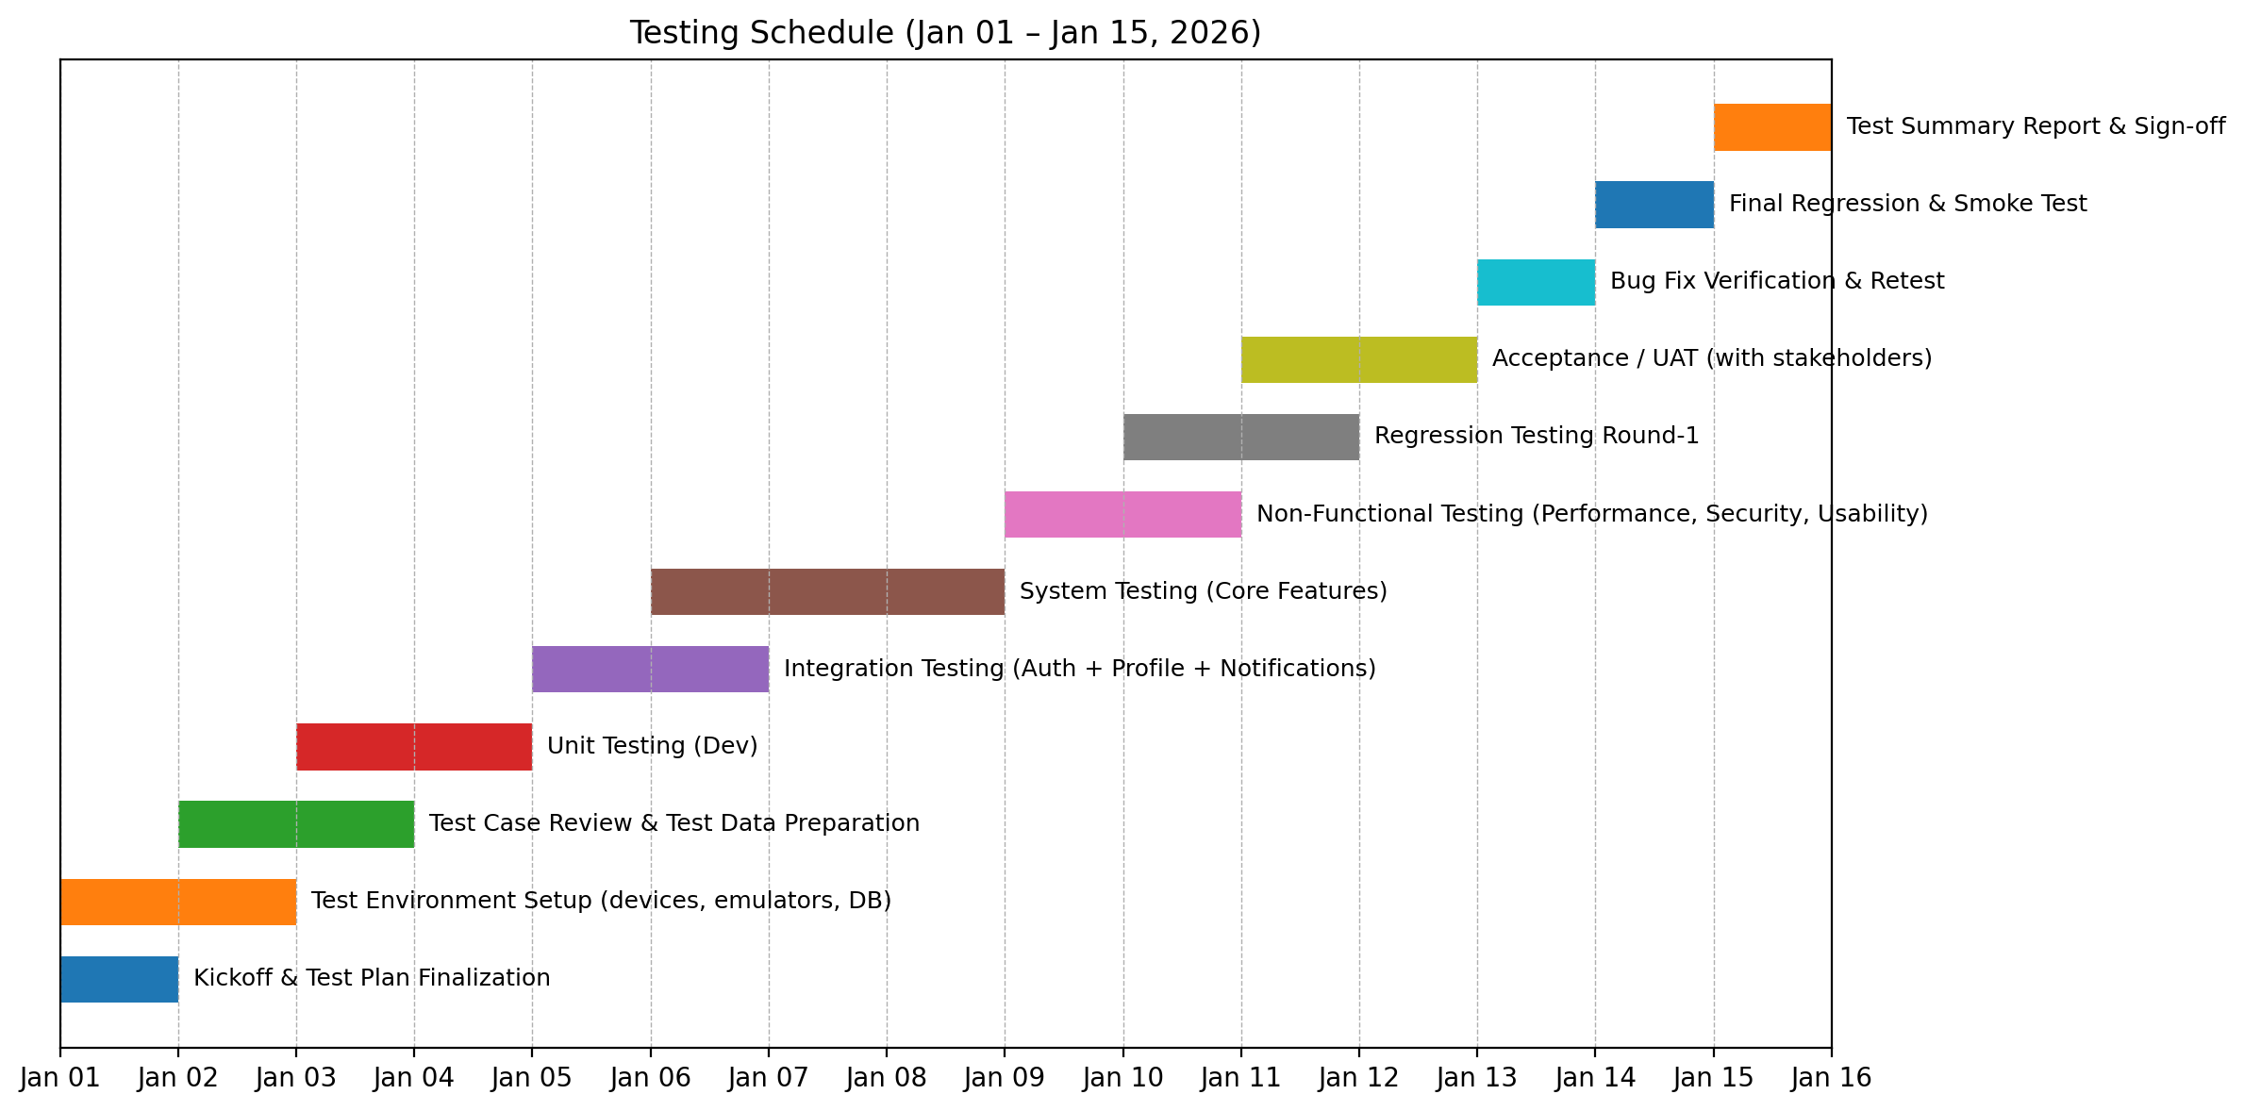
Figure 4: SHAAS Testing Schedule (Jan 01 – Jan 15, 2026)

PLANNING RISKS AND CONTINGENCIES
Key Risks:
- Device fragmentation may cause UI/permission issues.
- External APIs (weather/AQI/maps) can be slow or unavailable.
- Security/privacy risks if permissions or data storage are handled poorly.
- Short timeline (Jan 01–15) may limit testing coverage.
- Delays in UAT feedback can impact approvals.
Mitigation:
- Test critical workflows first (auth, profile, reminders, appointments, helpline).
- Use caching, fallback responses, or mock endpoints for API issues.
- Triage defects daily, focusing on high-impact issues.
- Reserve Jan 13–14 for retesting/regression.
- Use a checklist to ensure clear sign-off criteria.

APROVALS
Name | Role | Signature | Date
Zobayer Islam Jony | Prepared By (Team) |  | 15/01/2026
Shemanto | Prepared By (Team) |  | 15/01/2026
Afia Sultana | Prepared By (Team) |  | 15/01/2026
Course Instructor | Reviewed/Approved By

